Incident Management Process

Index
- Introduction
- Alignment with Service Agreement
- Potential Issues and Severity Classification
- Issue Categorization and Team Responsibilities
- Issue Resolution and Communication Process
- Incident Management Process Flowchart
- Call Handling Process Flowchart
- Metrics and Reporting
- Continuous Improvement
- Standardized Communication Guide for Incident Reporting

Introduction
This Incident Management Plan is designed to establish a structured and efficient approach for identifying, managing, and resolving incidents that may impact the services provided by Cognitio Analytics to Comcast. The plan aims to ensure compliance with the requirements outlined in the service agreement and to uphold the agreed-upon service levels.
By defining clear processes, roles, and communication protocols, this plan supports prompt incident detection, effective resolution, and continuous improvement to minimize disruption to Comcast’s operations. It aligns with industry best practices and emphasizes collaboration between Cognitio Analytics and Comcast to mitigate risks and ensure the reliability of critical services.
The plan outlines the framework for:
- Incident classification, reporting, and response.
- Timely communication and escalation procedures.
- Root cause analysis and preventive measures.
This document is a key component in fostering a strong partnership between Cognitio Analytics and Comcast, ensuring consistent delivery of high-quality services and rapid recovery in any disruption.

Alignment with Service Agreement
This section outlines how the Incident Management Plan aligns with the specific requirements and commitments in the service agreement between Cognitio Analytics and Comcast. It ensures all incident management activities are conducted per agreed-upon terms and expectations, fostering transparency and accountability.
Support Services: Vendor’s live personnel shall at all times be available to Comcast on a 12x5 (Monday through Friday 8 AM – 8 PM EST excluding US holidays) basis to respond to and resolve any performance or other problems with the Vendor Hosted Services (including but not limited to any issues reported by Comcast or end users, or which Vendor otherwise learns of) and to provide notices to Comcast required according to this exhibit and per the service levels herein. Automated monitoring tools shall alert the vendor (and if there is a Priority 1 or Priority 2 problem, the vendor will communicate to Comcast) personnel of issues on a 12x5 basis. The vendor shall record each material failure of the Vendor Hosted Services to comply with a service level in a problem tracking system, conduct a root-cause analysis as provided below if applicable to a particular service level failure, and report monthly (or more frequently if Comcast determines in good faith that it is necessary) in writing the results thereof to Comcast (and in a meeting if reasonably requested by Comcast).

2

Root Cause Analysis: In addition to its other obligations in this exhibit, for each Incident reported by Comcast, Vendor shall, as soon as practicable (but in no event later than forty-eight (48) hours after the resolution of the Incident), (a) perform a root-cause analysis to identify the cause of such Incident, and (b) provide Comcast with a report detailing the cause of, and procedure for correcting such Incident.

Response and Resolution Time
Priority | Response Time | Resolution Time
Critical | 2 hours | 8 hours
Urgent | 4 hours | 12 hours
Important | 1 Business Day | 2 Business Days
Monitor | 2 Business Days | One week
Information | One week | When commercially feasible

Priority Definition
- Critical: Vendor Hosted Service is completely unavailable. Essential facilities/tools do not work.
- Urgent: Non-essential features and/or functionalities of the Vendor Hosted Service are unavailable or not fully functional, significantly impairing Comcast’s ability to use the Vendor Hosted Service. Issues that could weaken system integrity over some time. Problems that can be ‘worked’ around in the short term but cause significant operational disruption in the long term.
- Important: Assistance required for technical or functional features of Vendor Hosted Service. Problems that exist, which cause minor operational difficulties with the Vendor Hosted Service.
- Monitor: General queries to Vendor. Undefined problems that may cause minor operational difficulties. Problems that require additional research and monitoring on the part of Comcast and Vendor to define and resolve.
- Information: Comments or suggestions on services, technical features, design, or other topics.

Potential Issues and Severity Classification
This section identifies common issues that may impact services and provides a structured framework for classifying these incidents based on their severity. This classification ensures a standardized approach to prioritizing and managing incidents in alignment with their potential impact on Comcast’s operations.
Priority Level | Category | Description
Critical | Application Availability | Complete application downtime
Critical | Authentication | System-wide authentication failure
Critical | Dashboards | All Dashboards are non-operational
Critical | Insights Studio | Inability to create new analyses
Critical | Insights Studio | Failure to run saved analyses
Urgent | Dashboard Operations | Some Dashboards are non-operational
Urgent | Insights Studio | Errors during analysis export
Urgent | Insights Studio | Bulk import failures
Urgent | Data Factory | The Data Factory module is completely non-operational
Urgent | Authentication | Login/module access problems for individual users
Important | Dashboard Operations | Dashboard export functionality failure
Important | Dashboard Operations | Dashboard refreshing issues
Important | General Features | General search functionality issues
Important | General Features | Support Centre accessibility or functionality problems
Important | General Features | Inability to access or manage "My Favorites"
Important | General Features | User navigation issues
Important | Insights Studio | Inaccessibility or errors with source cards
Important | Insights Studio | Issues in sharing analyses
Important | Insights Studio | Problems with editing, duplicating, or deleting analyses
Important | Data Factory | Operational issues within the Data Factory module
Monitor | Data Accuracy | Any data discrepancies or accuracy problems
Information | Feature Enhancements | Enhancement requests or non-critical feature suggestions

Issue Categorization and Team Responsibilities
This section categorizes potential issues based on their nature and assigns the corresponding teams responsible for their resolution. Clearly defining responsibilities ensures swift and efficient handling of incidents, minimizes service disruption, and aligns with Comcast’s operational requirements.
Issue Category |  | HTTP Error Codes for APIs/Pages | Team Ownership
User Issues | Incorrect credentials | 401 Unauthorized | Infra
User Issues | Incorrect conf | 403 Forbidden | Infra
User Issues | Account locked/disabled | 401 Unauthorized | Infra
User Issues | Incorrect input format | 404 - Not Found | Tech
User Issues | Forgotten Credentials | 401 Unauthorized | Infra
User Issues | Application crash | 500 Internal Server Error | Tech
User Issues | Session Expiry & Inactivity | 502 Bad Gateway | Tech
User Issues | Access/Permission | 401 Unauthorized | Infra
System Issues | Server outages or downtime | 502 Bad Gateway | Tech
System Issues | Database connection failures | 500 Internal Server Error | Tech
System Issues | High server load causing slowness | 502 Bad Gateway | Tech
System Issues | Timeout issues, long-running queries, or processes | 504 Gateway Timeout | Tech
System Issues | API failure | 500 Internal Server Error | Tech
System Issues | Data Services | 500 Internal Server Error | Tech
Configuration Issues | Incorrect application settings | 500 Internal Server Error | Tech
Configuration Issues | Incorrect database configuration | 503 Service Unavailable | Tech
Configuration Issues | Environmental misconfigurations | 503 Service Unavailable | Tech + Infra
Configuration Issues | Caching issues leading to outdated information | 503 Service Unavailable | Tech

Issue Resolution and Communication Process
This section outlines the step-by-step procedure for resolving issues reported via calls or emails, ensuring timely response and transparent communication with Comcast. The process is designed to meet the service level expectations defined in the agreement.
Production Support Email ID: productionsupport@cognitioanalytics.com
Helpdesk Email ID: helpdesk@cognitioanalytics.com
Cognitio Teams: comcast_support@cognitioanalytics.com
Telephone number: +1-973-245-9936
Email Initiated Reports
- Issue Reporting by Client
  - The client sends an email to the Production Support Email ID reporting an issue.
- Ticket Creation & Notification
  - A ticket is automatically created in the Helpdesk system.
  - The system triggers an email with the Ticket ID to the client for tracking purposes.
- Acknowledgment to the Client
  - The Support Agent acknowledges receipt of the issue via the Helpdesk system.
  - The acknowledgment email is sent only to the client, with the Helpdesk & Cognitio Team Email IDs in CC. Please refer “Acknowledgment Reply“ section from “Incident Email template” sheet for the mail format.
- Internal Escalation to Cognitio Team
  - The Support Agent forwards the issue to the relevant Cognitio team for investigation (Check “Roaster” sheet from Excel of ”Support Agents Information”).
  - The email is sent internally, with the Helpdesk ID and Cognitio Team Email IDs in CC ensuring the client is not present in the email thread. Please refer “Acknowledgment Reply“ section from “Incident Email template” sheet for the mail format.
- Follow-up via Call
  - The Support Agent calls team members as per the roster until someone responds. If the primary contact does not respond to the call, then try contacting other team members. If none of team members are picking the call, then try calling Team Owner.
  - If no acknowledgment is received within 30 minutes, the Support Agent calls again to ensure a response.
- Team Acknowledgment & Severity Confirmation (Assigned Team member will follow this step)
  - The assigned team member acknowledges the issue via email, specifying the “Severity” of the issue.
  - The response is sent to the email thread from Step 4, with “Reply All Option. Please ensure Helpdesk ID, Production Support, Cognitio Team Email IDs in CC ensuring the client is not present in the email thread.
- Severity & Resolution Time Notification to Client
  - The Support Agent informs the client of the severity level and contractual resolution time.
  - This email is sent in response to Step 3, with the Helpdesk ID and Cognitio Team Email IDs in CC. Please refer “Severity Determination” section from “Incident Email template” sheet for the mail format.
  - After sending above mail, please wait till half time gets over based on contractual resolution time.
- Issue Resolution & Internal Update (Assigned Team member will follow this step)
  - The respective team member resolves the issue and provides a resolution update on the mail to support agents with RCA.
  - The update is sent internally to the Production Email ID and Cognitio Team Email IDs, ensuring the client is not present in the email thread.
  - The response is sent to the email from Step 6, with the Helpdesk ID and Distribution List in CC.
- Final Resolution Update to Client
  - The Support Agent updates the client, sharing the RCA details which team member shared.
  - The email is sent in response to Step 7, with the Helpdesk ID and Cognitio Team Email IDs in CC. Please refer “Resolution Response” section from “Incident Email template” sheet for the mail format.
  - Before sending, all emails are marked as private to prevent internal conversations from being shared with the client.
- Ticket Closure
  - The Helpdesk Agent marks the ticket as closed in the software.
  - An automated email is sent to the client, confirming the closure of the issue.

Call Initiated Reports
- The client calls the Support Number
  - The client calls the designated support number to report an issue.
- Support Agent Answers & Logs the Issue
  - The Support Agent answers the call and informs the client that the call is being recorded for quality and training purposes.
  - The agent follows the scripted conversation guide (Check “Verbatim” sheet from Excel of ”Support Agents Information”) for collecting necessary details.
- Email Confirmation to Client
  - The Support Agent create new ticket via the Helpdesk Software on behalf of the person who calls to support Number. Add Name and email of that person while creating new ticket.
  - An auto mail with reference number trigger to that person automatically.
- Acknowledgment to the Client
  - The Support Agent acknowledges receipt of the issue via the Helpdesk system.
  - The acknowledgment email is sent only to the client, with the Helpdesk & Cognitio Team Email IDs in CC. Please refer “Acknowledgment Reply“ section from “Incident Email template” sheet for the mail format.
- Internal Escalation to Cognitio Team
  - The Support Agent forwards the issue to the relevant Cognitio team for investigation (Check “Roaster” sheet from Excel of ”Support Agents Information”).
  - The email is sent internally, with the Helpdesk ID and Cognitio Team Email IDs in CC ensuring the client is not present in the email thread. Please refer “Acknowledgment Reply“ section from “Incident Email template” sheet for the mail format.
- Follow-up via Call
  - The Support Agent calls team members as per the roster until someone responds. If the primary contact does not respond to the call, then try contacting other team members. If none of team members are picking the call, then try calling Team Owner.
  - If no acknowledgment is received within 30 minutes, the Support Agent calls again to ensure a response.

- Team Acknowledgment & Severity Confirmation (Assigned Team member will follow this step)
  - The assigned team member acknowledges the issue via email, specifying the “Severity” of the issue.
  - The response is sent to the email thread from Step 4, with “Reply All Option. Please ensure Helpdesk ID, Production Support, Cognitio Team Email IDs in CC ensuring the client is not present in the email thread.

- Severity & Resolution Time Notification to Client
  - The Support Agent informs the client of the severity level and contractual resolution time.
  - This email is sent in response to Step 3, with the Helpdesk ID and Cognitio Team Email IDs in CC. Please refer “Severity Determination” section from “Incident Email template” sheet for the mail format.
  - After sending above mail, please wait till half time gets over based on contractual resolution time.
- Issue Resolution & Internal Update (Assigned Team member will follow this step)
  - The respective team member resolves the issue and provides a resolution update on the mail to support agents with RCA.
  - The update is sent internally to the Production Email ID and Cognitio Team Email IDs, ensuring the client is not present in the email thread.
  - The response is sent to the email from Step 6, with the Helpdesk ID and Distribution List in CC.
- Final Resolution Update to Client
  - The Support Agent updates the client, sharing the RCA details which team member shared.
  - The email is sent in response to Step 7, with the Helpdesk ID and Cognitio Team Email IDs in CC. Please refer “Resolution Response” section from “Incident Email template” sheet for the mail format.
  - Before sending, all emails are marked as private to prevent internal conversations from being shared with the client.
- Ticket Closure
  - The Helpdesk Agent marks the ticket as closed in the software.
  - An automated email is sent to the client, confirming the closure of the issue.

Incident Management Process Flowchart
This section represents the entire incident management process, outlining the key steps and interactions from the instance an issue is reported (via email or call) to its resolution and closure. The flowchart offers a clear and concise overview of how incidents are handled, the responsible parties at each stage, and the escalation paths to ensure timely and effective resolution.
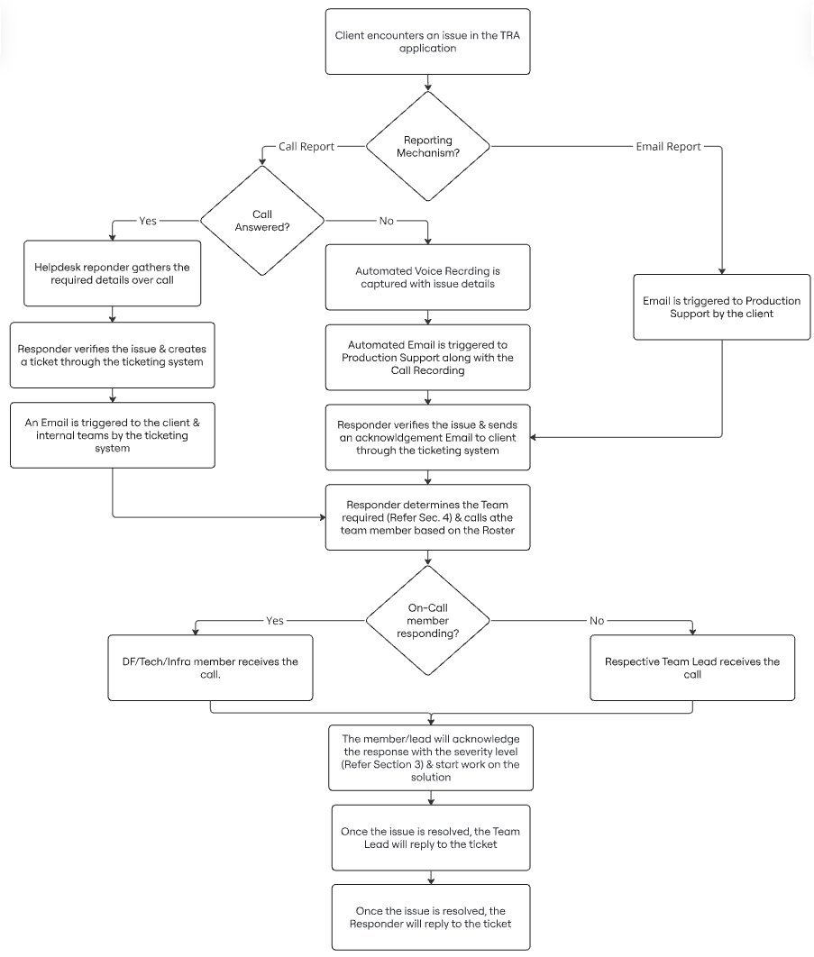

Call Handling Process Flowchart
This section illustrates the complete process for managing calls received during both on-hours and off-hours, detailing the steps taken for each call, including automatic responses, call transfers, and checks for working hours. The flowchart ensures that calls are efficiently handled in line with incident management protocols, providing a clear path for the call handlers to follow and ensuring timely issue resolution or escalation.
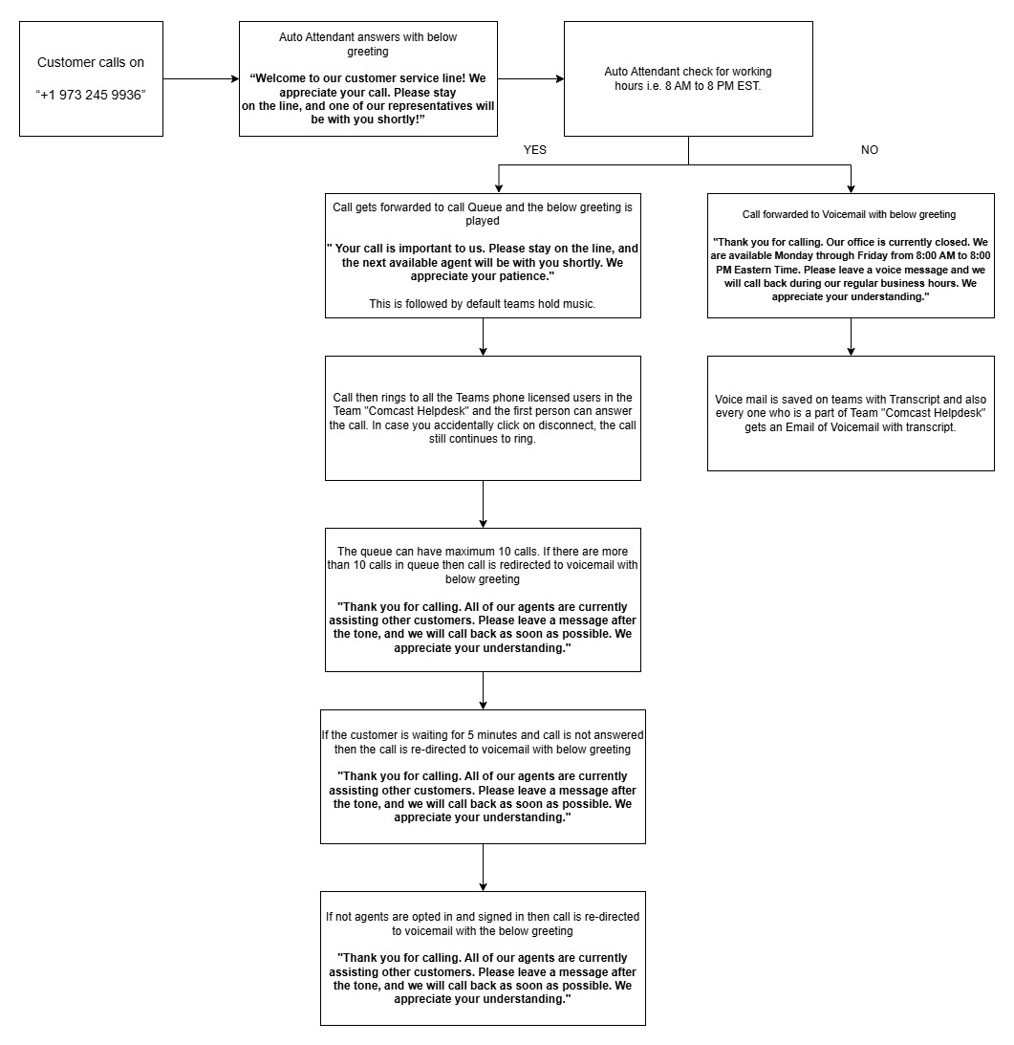

Metrics and Reporting
The section outlines the key performance indicators (KPIs) that will be tracked and reported monthly to measure the effectiveness of the incident management process. These metrics help assess the team's performance, identify areas for improvement, and ensure that the service levels agreed upon with Comcast are being met consistently.
Key Metrics to be Tracked
- Incident Volume
  - Description: Total number of incidents reported during the month.
  - Purpose: Helps identify trends and resource allocation needs.
  - Report: Total number of incidents by category (e.g., Critical, Urgent, Important).
- Response Time
  - Description: Average time taken to respond to an incident after it has been reported.
  - Purpose: Measures the responsiveness of the support team.
  - Report: Average response time per incident category.
- Resolution Time
  - Description: Average time taken to resolve incidents based on their severity level.
  - Purpose: Assess how quickly issues are resolved with the severity matrix.
  - Report: Breakdown of resolution times per severity level (Critical, Urgent, Important).
- SLA Compliance
  - Description: Percentage of incidents resolved within the agreed resolution times, as outlined in the service level agreement (SLA).
  - Purpose: Measures the organization's ability to meet client expectations.
  - Report: Percentage of incidents meeting SLA targets versus those that missed SLA.
Monthly Reporting Process
Each of these metrics will be tracked monthly and compiled into a Monthly Incident Management Report. The report will be shared with Comcast to ensure transparency and to demonstrate adherence to the service agreement. The report will include:
- A summary of overall performance metrics, with detailed breakdowns by incident severity and category.
- SLA compliance statistics, highlighting areas of improvement or issues.
- Key trends, including recurring issues or systemic problems.
- Recommendations based on analysis of the data, including improvements to the incident management process.
This reporting structure helps provide a comprehensive overview of incident management performance and ensures that all stakeholders, including Comcast, are kept informed about the service quality and ongoing improvements.

Continuous Improvement
The Continuous Improvement section focuses on ongoing efforts to enhance the incident management process, ensuring it remains efficient, effective, and aligned with client needs. This section outlines strategies for refining processes, increasing team performance, and ensuring that service delivery meets or exceeds expectations over time.

Objectives
- Enhance Incident Resolution Speed and Quality
  - Continuously optimize the resolution time for incidents, particularly high-severity issues, while ensuring the quality of solutions and the effectiveness of root cause analyses (RCA).
- Improve Customer Satisfaction
  - Focus on improving customer satisfaction by addressing feedback, identifying pain points, and reducing the number of reopened incidents.
- Optimize Resource Allocation
  - Ensure that resources (personnel, tools, etc.) are optimally allocated based on incident trends and severity levels. This includes ensuring that on-call and off-hours coverage is aligned with demand.
- Refine Classification and Prioritization
  - Improve the accuracy of incident classification and prioritization to ensure issues are handled appropriately and promptly based on their severity and impact on business operations.
Key Strategies for Continuous Improvement
- Root Cause Analysis (RCA) for Process Improvement
  - Each resolved incident will include an RCA to identify the underlying causes of the issue. This data will be analysed regularly to identify trends or recurring issues that can be addressed through process changes, training, or system improvements.
  - Action: Develop a feedback loop where insights from RCAs are integrated into training materials, process updates, and system enhancements.
- Regular Review of SLA Compliance
  - Conduct a quarterly or monthly review of SLA compliance to assess if the service targets are consistently met. When incidents fail to meet the SLA, the root causes (e.g., delays in response or resolution) will be investigated, and process adjustments will be made.
  - Action: Use this data to identify bottlenecks or areas where response or resolution times need improvement and introduce targeted solutions.
- Post-Incident Reviews (PIRs)
  - After high-priority or complex incidents, a Post-Incident Review (PIR) will be held with the relevant teams. This review will assess how the incident was handled, identify any lessons learned, and highlight areas for improvement in the response or resolution process.
  - Action: Implement changes based on PIR outcomes, such as refining escalation paths or updating communication protocols.
- Training and Development
  - Regular training sessions should be provided for the incident management team to improve their skills, stay updated on new tools and techniques, and ensure they understand the latest best practices.
  - Action: Use metrics and feedback to determine areas where the team may need additional training or resources (e.g., handling high-severity incidents or using new tools).
- Incorporation of Client Feedback
  - Actively seek feedback from Comcast through surveys and after-action reviews to understand their satisfaction with the incident management process and identify areas for improvement.
  - Action: Use client feedback to make process adjustments, improve communication, and ensure that the service delivery aligns with their expectations.
- Technology and Tool Enhancements
  - Regularly evaluate the tools and technologies used in the incident management process, looking for new solutions that could improve efficiency, reduce manual tasks, or enhance tracking and reporting.
  - Action: Invest in automation, advanced monitoring tools, or other technologies to improve incident detection, response times, and resolution capabilities.
- Incident Trend Analysis
  - Perform regular analysis of incident data to identify trends and patterns, such as recurring issues with specific systems, teams, or tools. This data will guide continuous improvement efforts by highlighting areas that require attention or upgrades.
  - Action: Develop and implement proactive solutions for common or recurring issues to reduce incident volume and improve overall service reliability.
- Performance Metrics Review
  - Regularly assess and update the performance metrics to ensure they accurately reflect the goals and objectives of the incident management process. This includes adding new KPIs, revising existing ones, or eliminating outdated measures.
  - Action: Adjust KPIs to align with changing business needs, such as new service agreements or revised SLA terms.
Continuous Improvement Cycle
- Identify Areas for Improvement
  - Regularly assess incident management performance, client feedback, and team performance data to pinpoint areas where improvements are needed.
- Implement Changes
  - Make targeted changes based on insights from metrics, PIRs, client feedback, and trend analysis.
- Monitor Effectiveness
  - Track the impact of implemented changes by revisiting the relevant metrics, customer satisfaction scores, and incident resolution data.
- Refine and Repeat
  - Refine the process further based on the monitoring results, ensuring that continuous improvement is an ongoing part of the incident management process.
By fostering a culture of continuous improvement, the incident management process will not only become more efficient and effective but will also adapt to changing needs, enhancing overall service delivery and ensuring client satisfaction.
- Standardized Communication Guide for Incident Reporting
Objective: This section provides standardized conversation templates for support agents handling incident reports via calls and emails. It ensures consistency, professionalism, and efficiency in client communication.
Call Handling: Sample Conversation
- Greeting & Call Recording Consent
  - Support Agent: "Hello, this is [Your Name] from Cognitio Analytics Support Team.”
  - “Before we proceed, I’d like to inform you that this call is being recorded for quality and training purposes. Let me know if you have any concerns regarding this.”
  - “How may I assist you today?"
- Issue Logging & Details Collection
  - Client: "I am unable to access the dashboard. It keeps showing an error message."
  - Support Agent: "Thank you for reporting this. May I have your name and email address for verification and further communication?"
  - Client: (Client provides details)
  - Support Agent: "I appreciate that. Could you please describe the issue in more detail? Are you experiencing this on all dashboards or just a specific one?"
  - "Have any other users in your team reported the same issue?"
  - "Can you share any error messages that appear on the screen?"
- Issue Acknowledgment
  - Support Agent: "Thank You for sharing the details. We will get back to you shortly with the issue clarification and expected resolution time."
- Escalation to the Relevant Team
  - Support Agent: "I will now escalate this to our technical team for further investigation. You will receive an acknowledgment email with your issue details and our next steps shortly."
  - "If any updates or additional information are required, we will reach out to you via email or call."
- Closing the Call
  - Support Agent: "Thank you for reaching out. We appreciate your patience, and we will keep you updated on the progress. If you have any further concerns, feel free to contact us at [Support Number] or via email at [Support Email]."
  - "Have a great day!"
Email Handling: Sample Communication Templates

Bug Report:
To : Client User
CC: CC: Productionsupport@cognitioanalytics.com, comcast_support@cognitioanalytics.com
From: productionsupp
×
- Email received at production support
- Email forwarded to helpdesk id
- Helpdesk ID creates a ticket
- Helpdesk ID sends a ticket Email to client user (comcast_support)

Platform Triggered Emails:
- Analysis Sharing: notifications@cognitioanalytics.com
- Bug Report: productionsupport@cognitioanalytics.com
- Write To Us:

UAT:
- From: uatsupport@cognitioanalytics.com
- CC: uatsupport@cognitioanalytics.com
- To: User
Dev:
- From:
Analysis Sharing:

Demo:
demosupport@cognitoanalytics.com

